Design and build batch data pipelines
In module 1, you built a strong foundation in batch data pipelines, understanding their role and common challenges. In module 2, you'll focus on the architectural and design principles required to effectively build a pipeline, and you'll explore how Cymbal Superstore can transform raw billing transactions into actionable insights.
Before any code is written or data is moved, a solid architectural design is paramount. This is especially true for batch data pipelines, because the challenge is no longer just processing data, but doing so at a massive scale, handling complex transformations, and ensuring both high performance and cost-efficiency.
By the end of this module, you will have a clear framework for how to approach the design of a large-scale batch data pipeline on Google Cloud, enabling you to make informed architectural decisions from the start of a project.
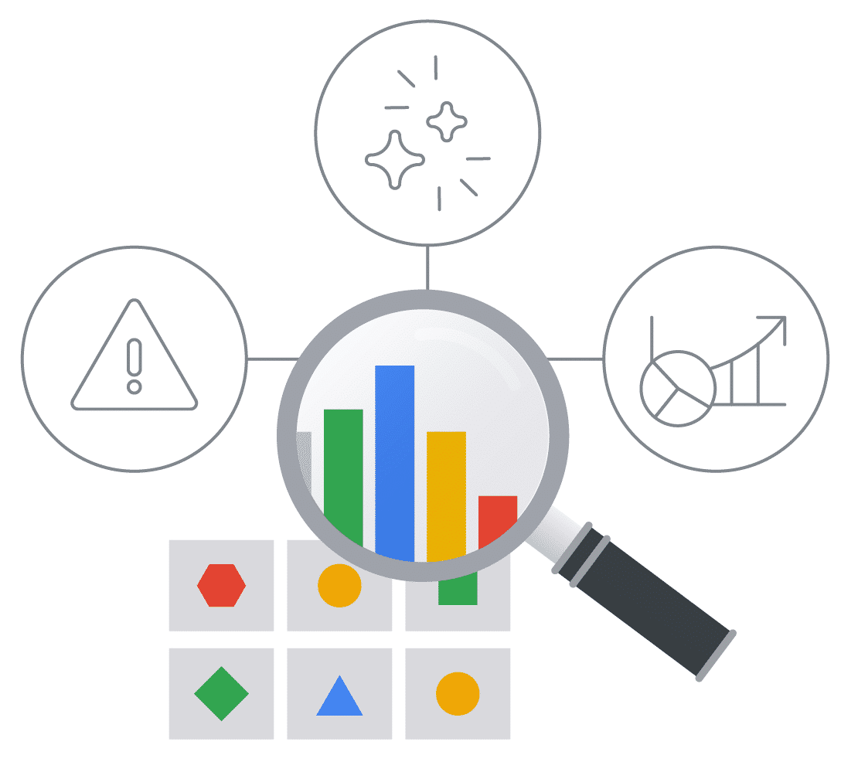
For Cymbal Superstore, its success depends on its ability to ingest and transform immense volumes of daily billing transactions to ensure accurate financial reporting and timely invoicing. The task is to create a solution to handle this high throughput and is sophisticated enough to perform complex logic across varied datasets.
Click the play button below to an overview of module 2.

Transcript
Welcome to Design and Build Batch Data Pipelines, module 2 of the Build Batch Data Pipelines course. This module is divided into three key lessons.
- In lesson one, batch data pipeline design, you'll explore core design strategies for scalable batch data pipelines and batch jobs for high throughput and cost efficiency.
- Then, in lesson two, large-scale data transformation, you'll focus on the principles of large-scale data transformations, use cases for complex joins and aggregations, and best practices for handling data sources and sinks.
- And finally, in lesson three, you'll optimize the batch pipeline by implementing techniques for analyzing and improving pipeline performance, identifying bottlenecks, and creating strategies for high throughput.

Pipelines solve business challenges
Cymbal Superstore's massive transaction data often overwhelms single servers, leading to delays and failures, especially during peak seasons like holidays.
Distributed processing is essential for ensuring scalable, timely financial reporting and processing large datasets, like customer loyalty data or supply chain logistics.

What is pipeline design
Pipeline design is the comprehensive process of conceptualizing, structuring, and implementing data processing workflows to efficiently move, transform, and analyze bounded datasets.
- Bounded datasets refer to data that has a fixed size and is available in its entirety before processing begins. The dataset is then processed as a batch.
- Unbounded datasets represent continuous streams of data, so data is processed in real-time.
Pipeline design is about making strategic choices to ensure your data pipelines are scalable, reliable, cost-effective, and meet your business's analytical needs.

Distributed processing for scale
Distributed processing is fundamental because it breaks down large tasks into smaller, independent sub-tasks that can run concurrently across multiple computing nodes, rather than being confined to a single machine.
The image below illustrates how distributed processing enhances batch pipelines:
- Start with a larger task or dataset, which contains the raw data.
- This is broken into smaller subtasks or data chunks.
- These subtasks are then processed in parallel by multiple compute resources that act as workers to transform the data.
- This parallel execution significantly boosts throughput.
The diagram also shows fault tolerance, where if a worker or data chunk fails, the subtask can be reassigned or retried (indicated by arrows returning to workers after a 'failed' step), ensuring the entire job is done despite individual component failures.
Click on each number in the image below, for detailed information of the following six components:
- Larger tasks
- Subtasks
- Worker nodes
- Job completion
- Subtask failures
- Worker level failures
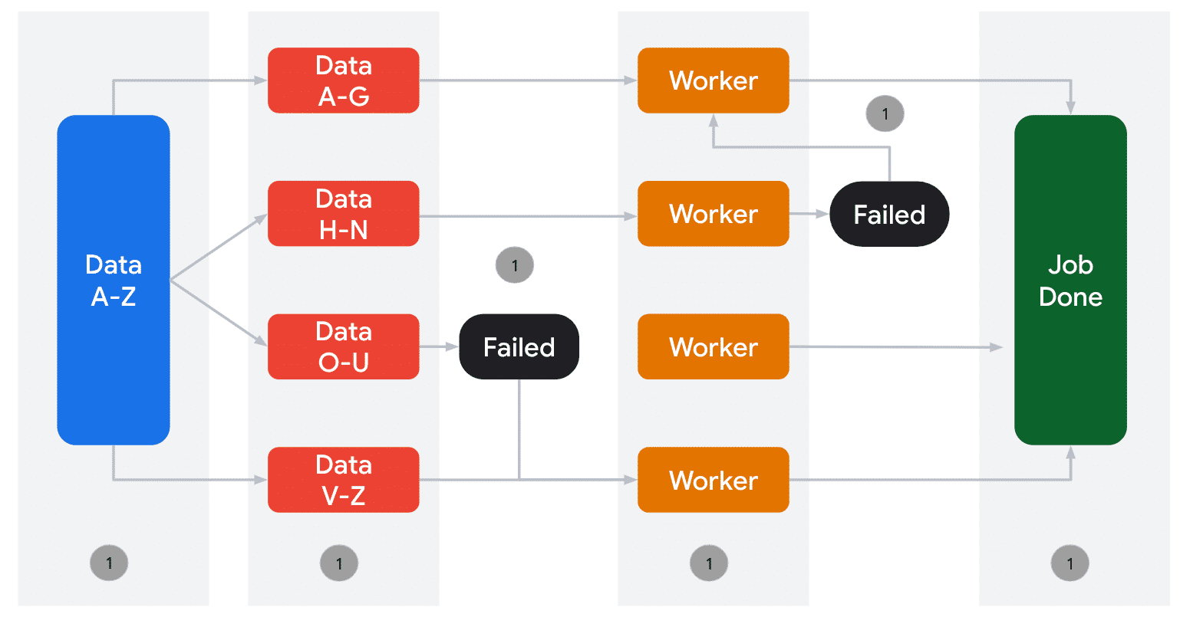

When failures happen
When a failure occurs between the larger task and a subtask (meaning the subtask itself, or the data for it, is faulty before being processed), it cannot be 'reassigned to a different worker' because the problem lies with the definition or integrity of that specific subtask itself, not with a worker failing to process it.
Resolution in this scenario typically involves:
- •
- Error Reporting/Logging: The system would likely log the failure, indicating that a particular subtask (or range of data designated for a subtask) is problematic.
- •
- Skipping (if permissible): In some cases, if the integrity of the overall job isn't critically dependent on that specific subtask's completion, the system might be configured to skip it and continue with other subtasks. This is less common in critical data pipelines.
- •
- Human Intervention/Data Curation: More often, this type of failure requires human intervention.

Distributed processing on Google Cloud
Dataflow (with Apache Beam) and Serverless for Apache Spark leverage distributed processing automatically. These services manage compute resources, orchestration, and scaling behind the scenes, allowing data engineers to focus on defining the data transformation logic without worrying about infrastructure management.
For Cymbal Superstore, this means engineers can quickly set up pipelines to process daily sales transactions efficiently without needing to manage server clusters.
- For a high level overview of Dataflow and its capabilities, check out this short video on Dataflow
- (opens in a new tab)
- .
- To learn more about Google Cloud Serverless for Apache Spark and its built in features, optimizations for AI/ML workloads, check out this blog post, "Google Cloud Serverless for Apache Spark: high-performance, unified with BigQuery
- (opens in a new tab)
- ."

Design for high throughput
Efficient processing of high-volume transactions is crucial. In the case of our fictional company, Cymbal Superstore, slow pipelines delay critical reports and impact invoicing.
High-throughput design ensures fast, cost-effective data ingestion, transformation, and delivery, directly supporting Cymbal Superstore's need for timely business intelligence.
High-throughput design aims to minimize processing time while maximizing resource utilization and reducing operational costs. To do this, as a data engineer, you will use a variety of strategies for optimizing batch jobs for high throughput and cost-efficiency.
Click each button to expand the 4 items and learn more.

Optimal Batch Sizing
Determining the right volume of data to process in a single operation to balance latency and efficiency.

Effective Data Partitioning
Dividing large datasets into smaller independent chunks (also called sharding) based on a key (e.g., date, region) to enable parallel processing and minimize data shuffling.
Data shuffling refers to the process of redistributing data across the nodes or workers in a distributed processing system, and it is a computationally expensive and potentially slow operation.

I/O Optimization
Using efficient file formats and techniques that minimize redundant reads and writes, often leveraging columnar storage and compression.

Efficient Resource Utilization
Maximizing the use of compute resources through effective parallelism, memory management, and workload balancing.

Dataflow and Serverless for Apache Spark
Dataflow and Serverless for Apache Spark inherently support high-throughput pipelines.
- •
- Dataflow achieves this through its managed services and dynamic work rebalancing, which automatically adapts to data volume.
- •
- Serverless for Apache Spark provides optimized connectors for BigQuery and Cloud Storage, facilitating rapid data movement.
Both services abstract infrastructure complexities, allowing Cymbal Superstore to scale its data ingestion capabilities to handle millions of transactions daily without manual server provisioning.
In the video below, you'll consider how the strategies for high throughput can be applied to Cymbal Superstore.
Click the play button to watch the video.

Transcript
Think back to Cymbal Superstore and its challenges.
- It generates a massive new data set daily.
- Its data comes from a broad range of sources and is in a variety of formats,
- It needs timely and accurate reports for Cymbal Superstore's daily transaction data.
Optimal Batch Sizing
- Optimal batch sizing means determining how many transactions are processed at once by a worker node.
- Too small a batch size can lead to excessive overhead, like frequent setup and teardown costs for each batch.
- Too large a batch size can overwhelm a worker's memory, lead to longer processing times for individual batches, and increase the risk of failure for that batch if an error occurs.
- Setting the right batch size for Cymbal's data ensures efficient use of cloud resources, minimizes processing costs, and delivers processed data when needed.
Partitioning
- Partitioning is about how a large data set is divided into smaller, non-overlapping, manageable batches, called partitions, based on a specific key, for example, customer ID, transaction date, or geographical region.
- Each record typically belongs to exactly one partition.
- This allows different parts of the data to be processed in parallel across multiple distributed worker nodes.
- If Cymbal Superstore's data is not effectively partitioned, like when the data is not evenly distributed across keys, it creates data skew.
- In a distributed environment, this means one worker node would be overloaded with a disproportionate amount of data while others sit idle, creating a severe bottleneck.
- This slows down the entire distributed pipeline and increases latency and costs due to inefficient resource utilization.
I/O Optimization
- I/O optimization for Cymbal Superstore focuses on efficiently making data reads and writes to and from distributed storage.
- File formats that are optimized for distributed systems, like Parquet, have two important features.
  - Columnar storage allows distributed processing engines to quickly read only the necessary columns.
  - Compression reduces storage costs and network transfer times.
Efficient Resource Utilization
- Efficient resource utilization is achieved by maximizing the use of compute resources across all worker nodes through effective parallelism, memory management, and workload balancing.

High throughput pipelines with Apache Iceberg
For a batch pipeline, high throughput isn't just about raw speed—it's about sustaining that speed reliably. Pipeline failures, data corruption, and management overhead are the biggest threats to throughput.
Apache Iceberg is an open table format that integrates reliability with performance, making high-throughput pipelines on Cloud Storage practical. It helps in three key ways:
Click each tab to learn more.
Errors and Idempotency
I/O Optimization
Performance
Iceberg's atomic transactions ensure that write operations are all-or-nothing.
This allows failed jobs to be safely and automatically retried without corrupting tables or creating duplicate data, keeping the pipeline flowing without manual cleanup.
In short, Iceberg provides the data reliability needed to turn a fast but brittle pipeline into a truly robust, high-throughput system. For more details on Apache Iceberg, check out the following article, What is Apache Iceberg?
(opens in a new tab)
, from the engineers at Google Cloud.

Review
- A: This problem is called data skew. It is solved by effective data partitioning (or re-keying) to distribute the data more evenly across workers.
- B: This is an I/O optimization problem. Columnar formats (like Parquet or ORC) allow the pipeline to read only the 5 columns needed, skipping the other 495.
- C: Processing millions of small files creates significant overhead. Optimal batch sizing (e.g., compacting them into larger files) is far more efficient for batch systems.

Iceberg's atomic transactions ensure that write operations are all-or-nothing.
This allows failed jobs to be safely and automatically retried without corrupting tables or creating duplicate data, keeping the pipeline flowing without manual cleanup.
Iceberg's detailed file-level metadata enables query engines to perform advanced file pruning, reading only the files necessary for a job.
This drastically reduces the amount of data scanned from Cloud Storage, providing a critical boost to speed.
Data access patterns change over time, but your pipelines need to remain fast.
Iceberg's partition evolution allows you to update the physical data layout to maintain optimal query performance without breaking downstream jobs.

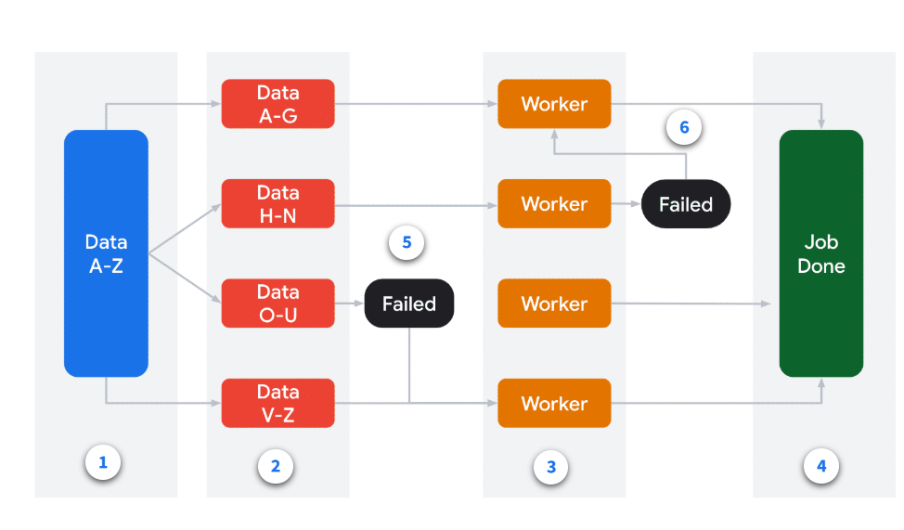
SUBMIT

